MAC-CPTM Situations Project
Situation 01: Sine 32°
Prepared at Penn State University
Mid-Atlantic Center for Mathematics Teaching and Learning
29 June 2005 – Pat Wilson, Heather Godine, and Jeanne Shimizu
Edited at Penn State University
Mid-Atlantic Center for Mathematics Teaching and Learning
12 February 2007 – Evan McClintock
23 February 2007 – Rose Mary Zbiek, M. Kathleen Heid
22 October 2008 – Heather Godine, Maureen Grady, Svetlana Konnova
6 September 2009 – M. Kathleen Heid

Prompt
After completing a discussion on special right triangles (30°-60°-90° and 45°-45°-90°), the teacher showed students how to calculate the sine of various angles using the calculator.
A student then asked, “How could I calculate sin (32°) if I do not have a calculator?”

Commentary
The set of foci provide interpretations of sine as a ratio and sine as a function, using graphical and geometric representations. The first four foci highlight 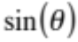 as a ratio, appealing to the law of sines, right-triangle trigonometry, and unit-circle trigonometry. The second three foci highlight 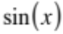as a function and use tangent and secant lines as well as polynomials to approximate.

Mathematical Foci

Mathematical Focus 1
Ratios of lengths of sides of right triangles can be used to compute and approximate trigonometric function values.
A ratio of measures of legs of a right triangle with an acute angle of measure x° can be used to approximate sin(x). Sin(x) can be approximated by sketching a 32°-58°-90° right triangle with a protractor or with software such as Geometer’s Sketchpad, measuring the length of the hypotenuse and leg opposite the 32° angle, and computing the sine ratio.
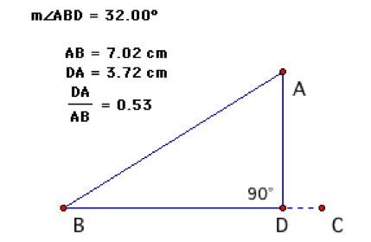

Figure 1

Hence,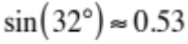.

Mathematical Focus 2
Coordinates of points on the unit circle represent ordered pairs of the form (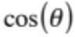,) that can be used to approximate trigonometric values.

The unit circle is the locus of all points one unit from the origin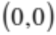. The equation for a circle with radius 1 centered at the origin is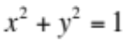. Consider the angle in standard position formed by the x-axis and a ray from the origin through a point A on the unit circle. Then, 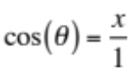and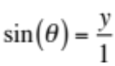. Hence, the coordinates of A are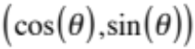, and another equation for a circle with radius 1 centered at the origin is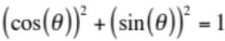.
Let A be positioned on the unit circle so that 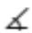ABD has degree-measure 32° Then, the signed length of segment AD is equal to sin (32°).
The signed length of segment AD is approximately 0.53 and so, 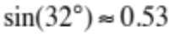
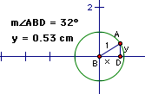

Figure 2

Mathematical Focus 3

The law of sines can be used to compute and approximate the sine function value through the measurement of geometric constructions.
The law of sines applies to any triangle in a plane. Consider triangle ABC, with sidelengths a, b, and c for 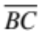, 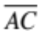, and 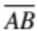, respectively. The law of sines states:

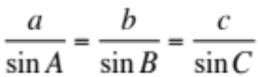.

Sin (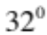) can be approximated by sketching any triangle the degree-measure of one of whose angles is and the degree-measure of another of whose angles has a known sine value (e.g., 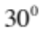, 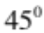, 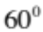, or 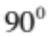).

For example, a triangle can be sketched (with software such as Geometer’s Sketchpad) with m A = and m B = (see Figure 3). Using the measure a, the measure of b, and the length of the leg opposite theangle, sin can be calculated using the law of sines.
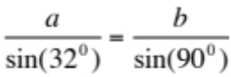

Because sin() = 1, then 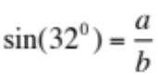
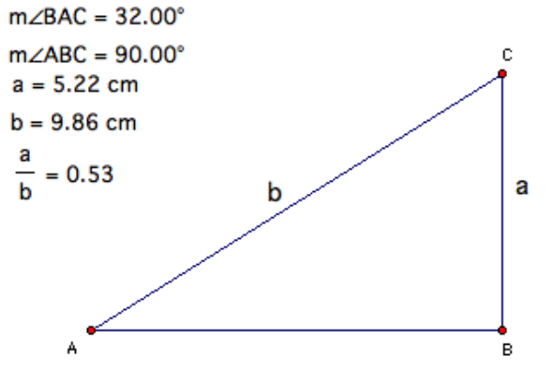

Figure 3

Hence,

In another example, a triangle can be sketched (with software such as Geometer’s Sketchpad) with m A = and m B = 30☑ (see Figure 4). Using the measure a, the measure b, and the length of the leg opposite the 30☑angle, sin can be calculated using the law of sines.
By the law of sines, 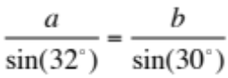
Because 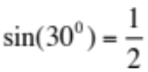, then 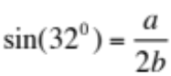.
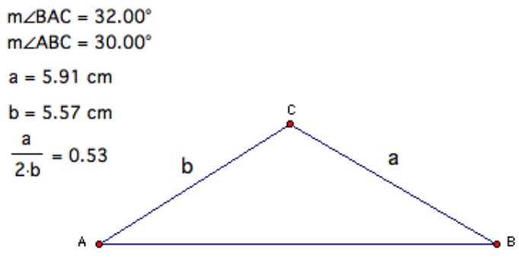

Figure 4

Hence,

Mathematical Focus 4
A continuous function, such as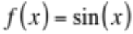, can be represented locally by a linear function and that linear function can be used to approximate local values of the original function.
The function is not a linear function; however, linear functions can be used to approximate non-linear functions over sufficiently small intervals.
Measuring angles in radians:
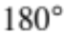is equivalent to radians, Therefore:
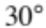is equivalent to 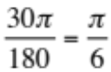 , or 0.5236 radians
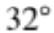is equivalent to 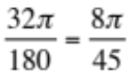 , or 0.5585 radians
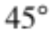is equivalent to 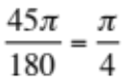 , or 0.7854 radians
Figure 5 shows the graph of the function and the graph of the secant line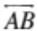, where the coordinates of A are 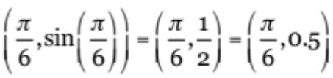 and the coordinates of B are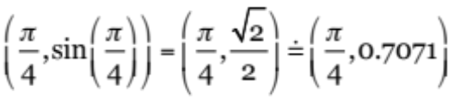. Since the function is approximately linear between points A and B, the values of the points on the secant line provide reasonable approximations for the values of between points A and B. Since sin(x) is concave down in the interval for x of 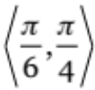 , the estimate for sin(32°) will be an underestimate.
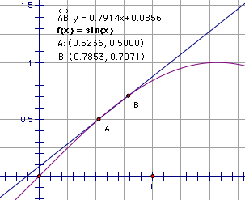

Figure 5

In Figure 6 point D on secant line with coordinates 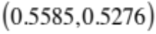 provides a reasonable approximation for the location of point C on with coordinates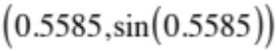.
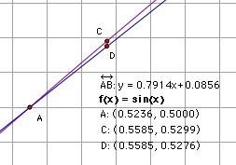

Figure 6
Therefore,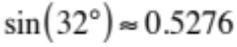.
An approximation for 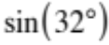 can also be found by using the equation for secant line. Since secant line passes through the points 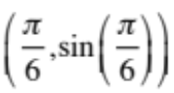 (0.5236, 0.5) and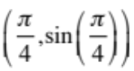(0.7853, 0.7071) , its equation can be approximated as follows:
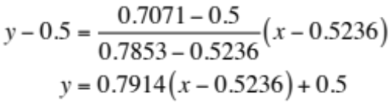
Therefore, 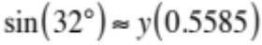=0.5276.

Mathematical Focus 5
Given a differentiable function and a line tangent to the function at a point, values of the tangent line will approximate values of the function near the point of tangency.
Since the function is differentiable, given a point 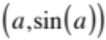 on, the line tangent to at can be used to approximate at a nearby point with x-coordinate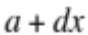. When 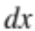is small, the value of 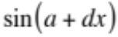 and the value of the tangent line at the point with x-coordinate will be very close. Using radian measure, is equivalent to , or 0.5585 radians

Consider a geometric interpretation of differentials and 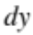 and their relation to 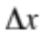 and 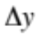 where a tangent line is used to approximate 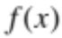 near a given value.
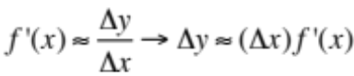
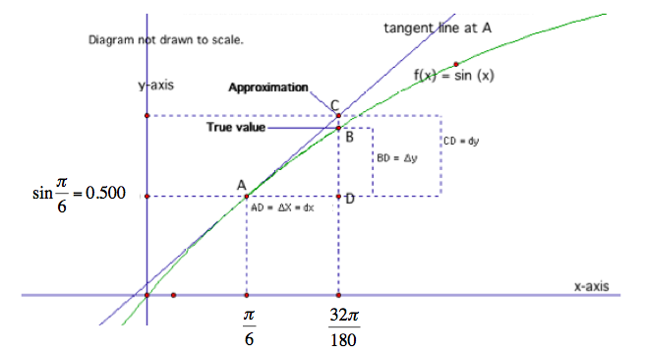

Figure 7

Since 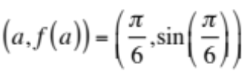 and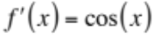,
Then,
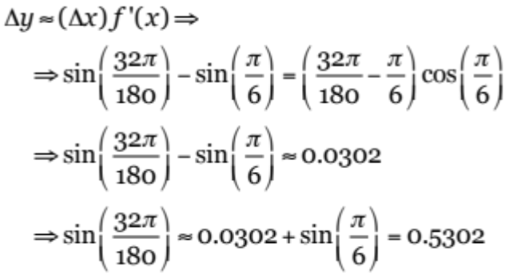.

Mathematical Focus 6
The theory of Taylor series provides the definition of the sine function based on the foundations of the real number system, independent of any geometric considerations.
The sine function could be defined as the infinite series. The following identity holds for all real numbers x, with angles measured in radians:
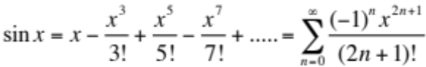
The sine function is closely approximated by its Taylor polynomial of degree 7 for a full cycle centered on the origin,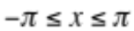.

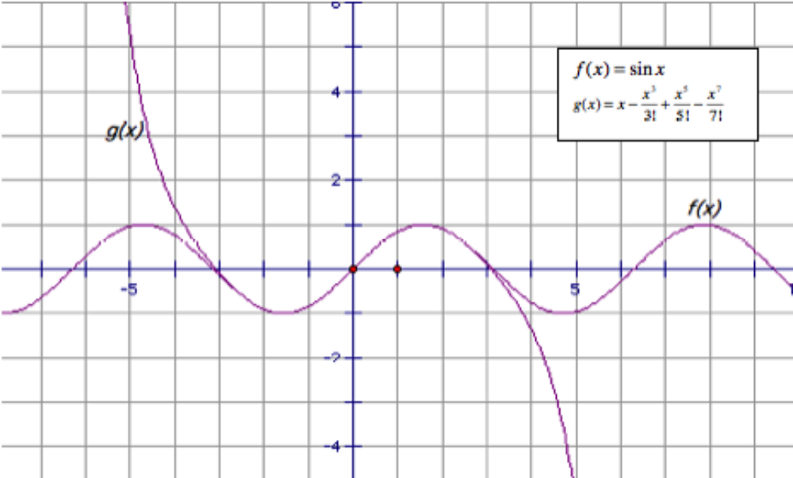 Figure 8

Post Commentary
Although they differ in the use of ratios versus the use of lines as approximation tools, all six methods involve approximations. The ratio methods depend on a definition of the trigonometric functions and therefore are not generalizable to other types of functions while the line methods depend on characteristics of continuous functions and therefore can be used for a wider range of functions.

